Paul Kafka

11/20/13

Embedded System Design

**Homework 8 – Custom Instruction BITSWAP**

# Snapshot of SOPC CI

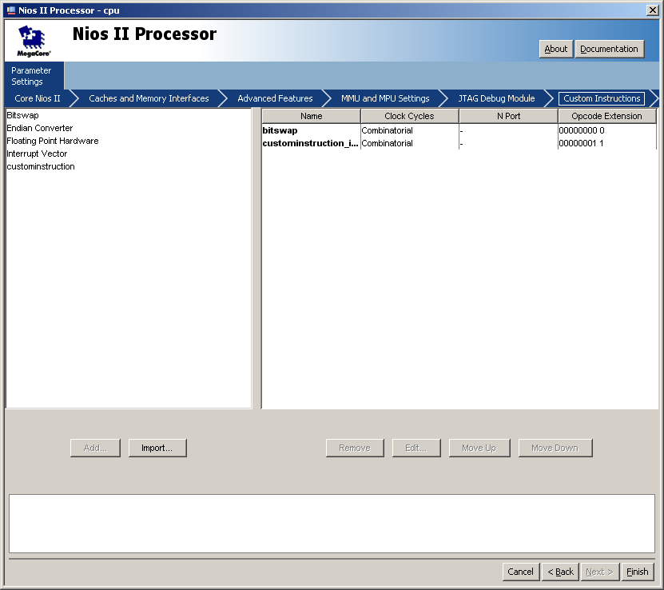

# C Code

#include <stdio.h>

#include <string.h>

#include <time.h>

#include <system.h>

#define switches (volatile char *) 0x01901050

#define leds (char *) 0x01901060

*/** look up the SW and LED base address from SOPC builder ***/*

void wait ( int s ) */* Custom wait since usleep() not available*/*

{

int u,v,sum=0;

for (u=1;u<100000;u++)

for (v=1;v<s;v++)

sum+=v;

}

int SW_BITSWAP(int a) {

int lsb, k, r=0;

int t=a;

for (k=0; k<8; k++) {

lsb = t & 1;

r = r*2 + lsb;

t >>= 1;

}

return(r);

}

int main( void )

{

int a=0;

int b=0;

int a_swap=0;

int i;

printf("This Homework 8 by Paul Kafka\n");

int start_time, finish_time, total_time, speed_up, c_time;

*//*

*//while (1) { /* run forever */*

*// a = *switches;*

*//*

*// a_swap = SW_BITSWAP(a);*

*//*

*// //a_swap = ALT_CI_CUSTOMINSTRUCTION_INST(a,b);*

*// //a_swap = ALT_CI_BITSWAP(a);*

*// // a_swap >>=24;*

*// *leds = a_swap;*

*//}*

*//-------------------------------SW_BITSWAP----------------------------------*

start_time = alt_nticks();

for (i=0; i<1000000; i++) {

a = *switches;

a_swap = SW_BITSWAP(a);

*leds = a_swap;

}

finish_time = alt_nticks();

total_time = ((finish_time - start_time)*1000) / alt_ticks_per_second();

c_time = total_time;

printf("SW_BITSWAP Time Used=%d ms\n", total_time);

*//------------------------------ALT_CI_CUSTOMINSTRUCTION_INST----------------*

start_time = alt_nticks();

for (i=0; i<1000000; i++) {

a = *switches;

a_swap = ALT_CI_CUSTOMINSTRUCTION_INST(a,b);

a_swap >>=24;

*leds = a_swap;

}

finish_time = alt_nticks();

total_time = ((finish_time - start_time)*1000) / alt_ticks_per_second();

speed_up = c_time / total_time;

printf("ALT_CI_CUSTOMINSTRUCTION_INST Time Used=%d ms\n", total_time);

printf("ALT_CI_CUSTOMINSTRUCTION_INST Speed Up=%d ms\n", speed_up);

*//-----------------------------ALT_CI_BITSWAP------------------------------*

start_time = alt_nticks();

for (i=0; i<1000000; i++) {

a = *switches;

a_swap = ALT_CI_BITSWAP(a);

a_swap >>=24;

*leds = a_swap;

}

finish_time = alt_nticks();

total_time = ((finish_time - start_time)*1000) / alt_ticks_per_second();

speed_up = c_time / total_time;

printf("ALT_CI_BITSWAP Time Used=%d ms\n", total_time);

printf("ALT_CI_CUSTOMINSTRUCTION_INST Speed Up=%d ms\n", speed_up);

*//--------------------------------------------------------------------------*

return 0;

}

# Measurements (Terminal Output)

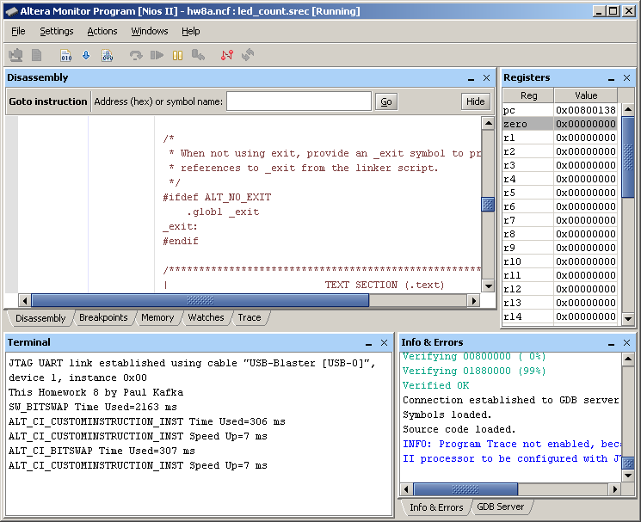

# Camera Images

